IST 363

Lab 06

This Lab Covers
- Bootstrap Icons and Components

Lab Corrections
- If you didn’t get a perfect score on lab 5, check your corrections list comments in blackboad. Submit the url to your corrections for this part.

Warmup

  - Check out the docs for Bootstrap icons here: https://icons.getbootstrap.com/. How do you get the following icon to display on the page?

  - What link do you need in the <head> to include for bootstrap icons?
  - Pick three components from this list and give a real world website scenario where you would use them. For example, if I gave you the cards component then you could say – “this component could be used to show price comparisons”. (Don’t just tell me what it does – I’m looking for you to imagine something bigger.)
Alerts  Badge  Breadcrumb  Buttons  Button group | Collapse  List group  Modal  Navbar  tabs | Offcanvas  Pagination  Placeholders  Popovers  Progress | Scrollspy  Spinners  Toasts  Tooltips

Bootstrap Page 2
- Expanding your Portfolio Page
This week you will be editing your portfolio page from last week’s lab. To get started, make a copy of the file.
  - Make it bluer.
Customize the colors on the site to make it bluer. The navigation and footer should be a shade of navy. The light gray backgrounds behind Customer Reviews and the form should be a light blue. All the headings should be a shade of blue. You don’t need to use the exact same colors as me.
  - Convert the images to a slide show (Bootstrap carousel component). Note that I am displaying the images at 100% width and about half the height.
  - Use bootstrap cards to make the Customer Reviews area. Make sure to add the bootstap stars icon next to the heading. The yellow stars I did with the HTML character code &#9734;
  - Use a Bootstrap accordion to make a FAQs area with at least 4 questions. Feel free to use lorem ipsum text here.
  - Make a bootstrap “Get in Touch” form.

See the screenshots below
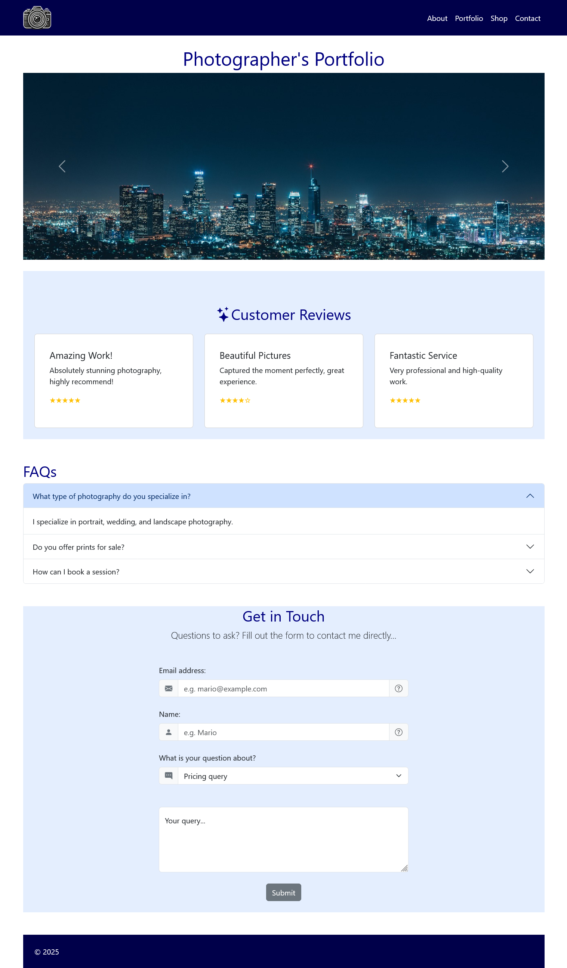 | 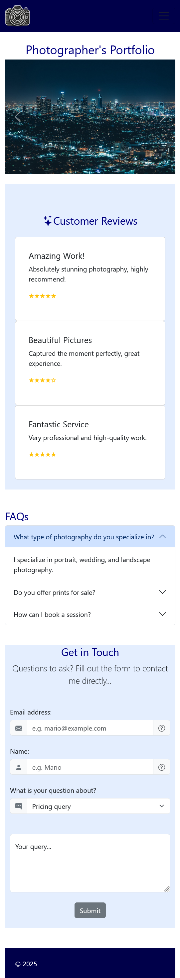

What to hand in
Note that if any URL doesn’t work for me, you will get a zero on this part. Ensure github.io is part of the URL in the address bar. If it’s not, you haven’t given me the correct link.
- For the corrections hand in the URL of the corrected page.
- For the warmup questions, paste your answers into the template provided in Blackboard.
- For the main page, hand in the URL
Use the answer template!

